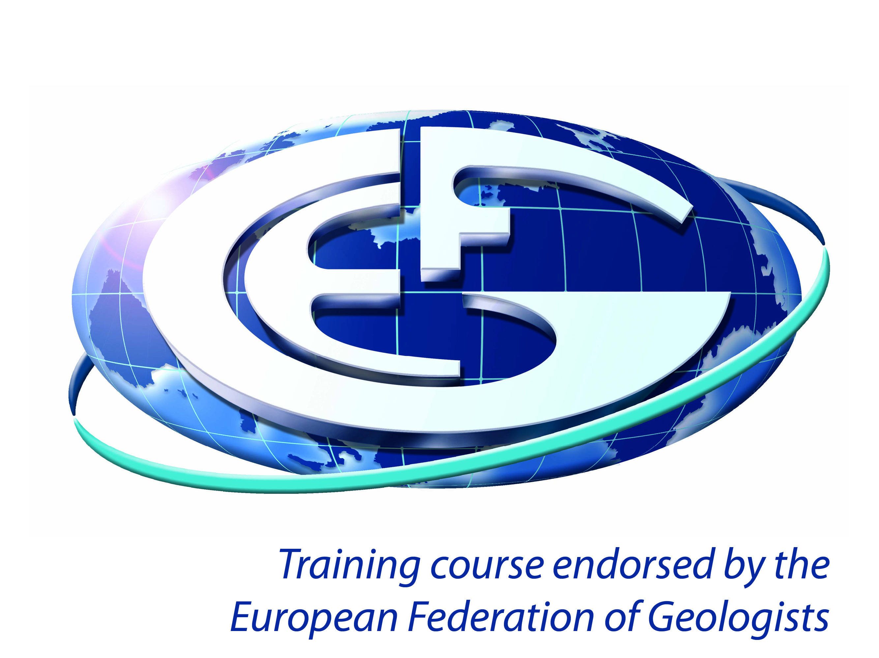
European Federation of Geologists (EFG)
Training course endorsement programme

Guidelines for course providers and application form

Benefits of endorsement

- The use of EFG’s “endorsed training logo” (see above) on your course materials, advertising and website;
- Your course listed on EFG’s website with a link to your own website;
- A listing in the Training section of Geonews (EFG’s monthly newsletter disseminated to around 40.000 geoscientists all over Europe;
- 20% discount on placing your company advertisement in one of EFG’s communication tools (more information: http://eurogeologists.eu/how-to-sponsor-efg/).

How does the endorsement programme work?

To apply, please complete the attached application form and return it to us. Ideally you should allow 2-3 months until the first date that the course is running on. We will assess your application and can usually give a decision within 28 days.

After each course, participant feedback forms must be collected and sent to us with a completed summary sheet within one month (approximately) of the course. Endorsement is valid for 3 years, subject to receipt of satisfactory feedback from participants. All courses must be submitted for re-endorsement after 3 years.

Course providers are encouraged to continue to advertise their course(s) through the European Federation of Geologists by sending in new date/venue/cost details, within the 3 years after endorsement. When a previously endorsed course is repeated the following conditions apply:

- When there is a change within this period in the personnel delivering the course, or when improvements to the content are made specifically in response to feedback from participants, details should be submitted to EFG.
- When the course content is changed by more than 25%, for any reason, a new application needs to be submitted.

Criteria for endorsement

To be endorsed a course must satisfy the criteria below:

- The course should have clearly defined objectives and be well-targeted at the intended audience in terms of subject content and course delivery
- Course presenters should have suitable qualifications and experience
- Course materials should normally be provided and any materials should be well-matched to the course content and objectives
- Feedback from course delegates must be collected (see application form for details). We will provide a standard delegate feedback form and would prefer this to be used.

How much does it cost?

There is no application fee, but every course should offer a 20% discount on the course registration fee to European Geologists title holders (EurGeol).

Application for course endorsement

Please complete and return this form to:
Pierangelo Bianco, European Federation of Geologists, Rue Jenner 13, 1000 Brussels, Belgium
or email to info.efg@eurogeologists.eu

Training provider details

Contact Name

Organisation

Address

Telephone

Email

Have you been approved before? (Please give dates)

Course details

Title

Venue address

Date(s) of course

Outline of content

Objectives
(Complete as appropriate)
Fee for course participants

(Please list main categories, including the cost for EurGeol title holders)
Who is the course aimed at? (e.g. job roles, level of experience etc.)

Is this a new course or has it been run before?
Course presenter(s)  Please attach CVs for the main course presenters detailing their relevant qualifications and experience. |  | Name of presenter(s):  CVs attached?  (Full CVs are required for training courses, for other CPD events such as seminars with several speakers a short summary or biography is sufficient.)
What course materials are provided?
On successful completion of the course, are delegates awarded any credits or other certification?

If so, please provide details.

I confirm that the information supplied is correct to the best of my knowledge.

I undertake to collect feedback from course participants on the standards of:
- course content
- course materials
- course presenters
- venue/facilities
- general administration
- overall rating

and to supply the European Federation of Geologists with the completed feedback forms plus a summary sheet within 28 days of the course.
Signature
Date – please complete even if returning by email

If you have any queries please contact Pierangelo Bianco on +32 2 788 76 31 or email pierangelo.bianco@eurogeologists.eu.

